Genetics

# mendel – basic principle of heredity

## pre-mendelian theories of inheritance

Three errors in interpreting the results of selective breeding were particularly misleading:

* the idea that one parents contributes most to an offspring’s inherited features
* the pangenesis theory (inheritance of acquired characteristics (Lamarck)
* the blending inheritance theory, the idea that parental traits become mixed and forever changed in offspring, as when blue and yellow pigments merge to green. This theory may have grown out of a natural tendency for parents to see a combination of their own traits in their offspring. However, it could not explain the differences between biological brothers and sisters nor the persistence of variation within extended families

## mendel’s scientific approach

What did Mendel do differently from those who preceded him?

* He chose the garden pea as experimental model. Why?
  + Each pea flower has both male and female organs, which made it easy to self-fertilize (both egg and pollen come from the same plant) or cross-fertilize plants (Mendel removed the male sex organs from the flowers of one plant and then he brushed pollen from the other plant onto the female organs of the first plant)
  + Large number of individuals within a relatively short growing season
  + Lots of varieties
  + Easy to grow and to breed
* Mendel examined the inheritance of clear-cut alternative states of particular traits. He could trace unambiguously the transmission of such either-or traits, because no intermediate form existed. These traits are called **discrete traits** (the opposite are continuous traits, such as height and skin colour)
* He only used true-breeding lines. These lines are also called inbred because they have been mated only to each other for many generations. In his experiment, Mendel cross-fertilized pairs of plants to produce **HYBRIDS**, **offspring of genetically dissimilar parents**
* Mendel made reciprocal crosses in which he reversed the characteristics of male and female parents, thus controlling whether a particular characteristic was transmitted via the egg cell within the ovule or via a sperm cell within the pollen. Because the progeny was similar, Mendel demonstrated that the 2 parents contribute equally to inheritance.
* Mendel was the first person to **study inheritance in quantitative manner**
* Mendel used a **scientific method**: from results he formulated hypothesis and carried out new experiments to prove it

## monohybrid crosses

Once Mendel had isolated pure-breeding lines for several sets of characteristics, he carried out a series of mating between individuals that differed in only one trait. In each cross, one parent has one form of the trait, and the other parent has the antagonistic characteristic.

Mendel planted pure-breeding green peas and pure-breeding yellow peas and allowed them to grow into the **PARENTAL GENERATION** (P). When the plants had flowered, he brushed the stigma of green-pea plant flowers with pollen from yellow-pea plants (and vice versa). He found out that the peas produced were all yellow. These yellow peas, progeny of the P generation, were the first filial (F₁) generation.

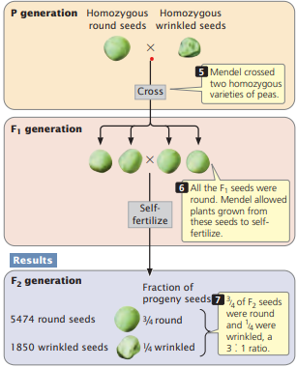To learn whether the green characteristic had disappeared entirely or remain intact but hidden in these F₁ yellow peas, Mendel planted them to obtain mature F₁ plants that he allowed to self-fertilize. Such experiments involving hybrids for a single trait are called monohybrid crosses. He the harvested and counted the peas of the resulting second filial (F₂) generation, and he obtained an almost perfect ratio of 3 yellow : 1 green.

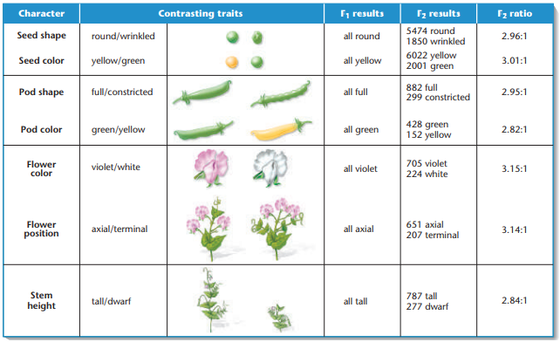

The presence of green peas in the F₂ generation was irrefutable evidence that blending had not occurred. If it had, the information necessary to make green peas would have been lost irretrievably in the F₁ hybrids. Instead, the **information remained intact**, and these peas were indistinguishable from their grandparents.

Mendel concluded that **two types of yellow peas must exist: those that breed true like the yellow peas of the P generation, and those that can yield some green offspring like the yellow F₁ hybrids**. This second type contains latent information for green peas.

He called the **characteristic that appears in all the F₁ hybrids** **DOMINANT**, and the **antagonistic characteristic that remains hidden in the F₁ and reappears in F₂ generation** **RECESSIVE**.

Mendel proposed that for each trait, every plant carries **two copies of a unit of inheritance**, receiving one from its maternal parent and the other from paternal parent. Today, we call these units of inheritance **GENES**.

Mendel further proposed that **each gene comes in alternative forms**, and combination of these alternative forms determine the contrasting characteristics he was studying. Today we call the alternative forms of a single gene **ALLELES** (the gene for pea colour, for example, has yellow and green alleles).

**Individuals having two different alleles of a single gene** are **MONOHYBRID**.

## mendel’s first law: the law of segregation

If a plant has two copies of every gene, how does it pass only one copy of each to its progeny?

Gametes are specialized cells that carry genes between generations. Mendel imagined that during the formation of the eggs and sperm, the two copies of each gene in the parent separate (or segregate) so that each gamete receives only one allele for each trait. At fertilization, a sperm with one allele unites at random with an egg carrying one allele, restoring the two copies of the gene for each trait in the fertilized eggs, or zygote.

Mendel’s law of segregation: ***the two alleles of each gene separate (segregate) during gamete formation, and then unite at random, one from each parent, at fertilization****.*

(somatic cells, that have two copies of each gene, ≠ gametes, which bear only a single copy of each gene)

Mendel invented a system of symbols that allowed him to analyse all of his crosses in the same way. He designated **dominant alleles with capital letters**, and **recessive ones with a lowercase**, so the pure-breeding plants are either YY or yy, while Yy is a hybrid.

To visualize what happens when the Yy hybrids self-fertilize, we set up a **PUNNETT SQUARE** (named after Reginald Punnett, 1906). The square provides a simple and convenient method for tracking the kinds of gametes produced, as well as the combinations that might occur at fertilization.

The Punnett square illustrates two rules of probability:

* **PRODUCT RULE**: ***the probability of two or more independent events occurring together is the product of the probabilities that each event will occur by itself****.*

Probability of event 1 *and* event 2 = probability of event 1 · probability of event 2

* **SUM RULE**: ***the probability of either of two mutually exclusive events occurring is the sum of their individual probabilities.***

Probability of event 1 *or* event 2 = probability of event 1 + probability of event 2

The law of segregation was a hypothesis that explained the data from simple crosses involving monohybrid peas, but Mendel needed to perform additional experiment to check its validity. Mendel’s hypothesis made the testable prediction that the F₂ should have two kinds of yellow peas (YY and Yy) but only one kind of green pea (yy). In addition, this hypothesis predicted that the YY and Yy yellow peas in the F₂ should be present in a ratio of 1 YY : 2 Yy.

To verify these expectations, Mendel allowed self-fertilization and counted the type of F₃ progeny and he was right.

At the end, he was able to conclude that the segregation of dominant and recessive alleles during gamete formation and their random union at fertilization could indeed explain the 3:1 ratios he observed whenever he allowed hybrids to self-fertilize.

Plants showing a dominant characteristic can be either pure-breeding or hybrid, how can you distinguish one from the other?

For self-fertilizing plants, you observe the appearance of the next generation. But what about the species that do not self-fertilize?

Some definitions:

* **PHENOTYPE:** **observable characteristic**
* **GENOTYPE: pair of alleles carried by the individual**
* **HOMOZYGOTE: two copies of the same allele** (YY or yy)
* **HETEROZYGOTE: two alternative alleles** (Yy) 🡪 the phenotype of a heterozygote defines which allele is dominant

Now we can look at the method Mendel devised for deciphering the unknown genotype responsible for a dominant phenotype. We’ll call this genotype Y-, where the dash represents the unknown allele. This method, called the testcross, is a mating in which an individual showing the dominant phenotype is crossed with the recessive phenotype. If the dominant phenotype derives from a homozygous genotype, all the offspring of the test cross will show the dominant yellow phenotype; if the dominant parent of unknown genotype is a heterozygous hybrid, half of the progeny will be green.

## dihybrid crosses

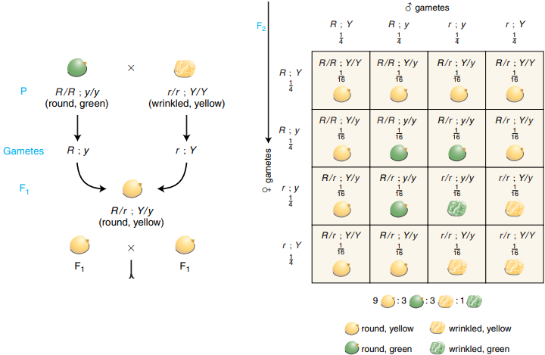

Mendel asked himself how two pairs of alleles would segregate in a dihybrid (organism that carries two different alleles of one gene and two different alleles of another gene). To construct such a dihybrid, Mendel mated true-breeding plants grown from yellow round peas (YYRR) with true-breeding plants grown from green wrinkled peas (yyrr). He obtained the result shown in the picture.

Mendel could not predict the outcome of this mating. Would all the F₂ progeny be parental types that looked like either the original yellow round parent or like the green wrinkled parent?

He obtained some **new combination of characteristics that were not seen in the parental lines**. New phenotype combinations like these are called recombination types.

## mendel’s second law: independent assortment

Mendel inferred the biological mechanism of that shuffling: the independent assortment of gene pair during gamete formation: **d*uring gamete formation, segregating pairs of unit factors (alleles) assort independently of each other****.* Because the genes for pea colour and pea shape assort independently, the allele for pea shape in a gamete carrying Y could with equal likelihood be either R or r. Thus, the presence of a particular allele of one gene provides no information about the allele of the second gene.

# cromosomes and inheritance

## genes reside in chromosomes

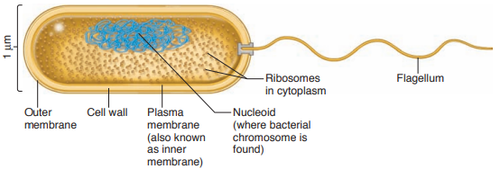

Procaryotes: circular chromosome in the cytoplasm (nucleoid)

These cells divide by binary fission. The chromosome replicates to produce two identical copies. These two copies segregate from each other, with one copy going to each daughter cell.

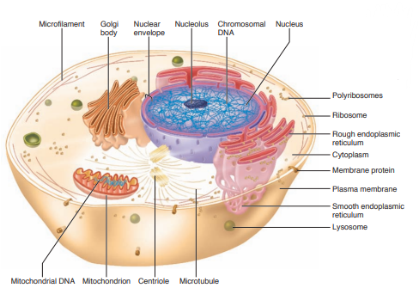

Eukaryotes: linear chromosomes in the nucleus

For eucaryotic cells, there are two different cell division processes: mitosis and meiosis.

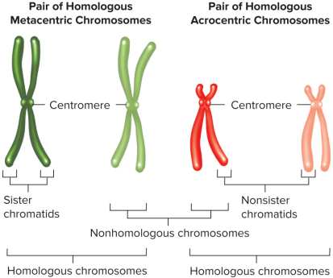Scientists analysed the chromosomal makeup of a cell when the chromosomes are most visible – at a specific moment in the cell division (metaphase). At this time, individual chromosomes have duplicated and condensed from thin threads into compact rodlike structure. Each chromosome now consists of two identical halves known as **SISTER CHROMATIDS**. The specific point at which sister chromatids are attached to each other is called **CENTROMERE**. Each sister chromatid has its own centromere, but in the duplicated chromosome, the two sister centromeres are pull together so tightly that they form a constriction within which the two centromeres cannot be resolve from each other.

Geneticists often describe chromosomes according to the location of the centromere:

* **metacentric chromosomes**: the centromere is more or less in the middle
* **acrocentric chromosomes**: the centromere is close to one end

**Chromosomes that match in size, shape, and banding** are called **HOMOLOGOUS CHROMOSOMES**, or homologs. The two homologs of each pair contain the **same set of genes**, **although for some of those genes they may carry different alleles** (one chromosome from the father and one from the mother). The gametes that unite in fertilization to produce the **DIPLOID** (2n) somatic cells have nuclei that contain only one set of chromosomes, **HAPLOID** (n), consisting of one member of each pair.

**Nonhomologous chromosomes carry completely unrelated sets of genes**.

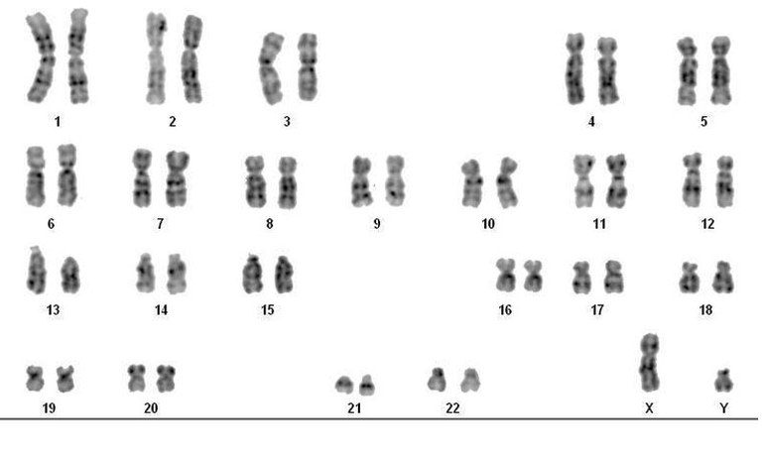To study the chromosomes of a single organism, geneticist arrange micrographs of the stained chromosomes in homologous pairs of decreasing size to produce a **KARYOTYPE**. The karyotype of a human male shows 44 chromosomes in matching pairs, known as autosomes, and two unmatched chromosomes, X and Y, that are called sex chromosomes.

Through thousands of karyotypes on normal individuals, cytologists (scientist who use the microscope to study cell structure) have verified that the cell from individuals of the same species contain the same number of chromosomes**. Differences in the size, shape, and number of chromosomes reflect differences in the assembled genetic material that determines what each species looks like and how it functions**. The number of chromosomes does not always correlate with the size or complexity of the organism.

## mitosis

The repeating pattern of cell growth and division is called **cell cycle**. Only a small part of the cell cycle is spent in division (M phase); the period between division is called **INTERPHASE**.

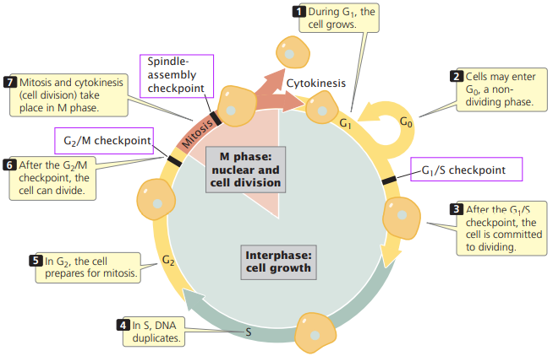Interphase consist in 3 parts:

* **GAP 1** (G₁): lasts from the birth of a new cell to the onset of chromosome replication. It is a period when the chromosomes are neither duplicating nor dividing. During this time, the **cell achieves most of his growth** by using the information from its genes to make the materials it needs to function normally.
* **SYNTHESIS** (S): is the time when the **cell duplicates its genetic material** by synthesizing DNA. During duplication, each chromosome doubles to **produce identical sister chromatids** that are joined to each other at their centromeres. The genetic material must be copied exactly so that both daughter cells received identical sets of chromosomes.
* **GAP 2** (G₂): is the interval between chromosome duplication and the beginning of mitosis. During this time, the cell may grow, and it also **synthesize proteins** that are essential to the subsequent steps of mitosis.

In addition, during interphase **an array of microtubules becomes visible outside the nucleus**. The microtubules radiate out into the cytoplasm from a single organizing centre known as the **CENTROSOME**, usually located near the nucleus. In animal cells, the core of each centrosome is a pair of small darkly staining bodies called **CENTRIOLES** (plant cells does not have them).

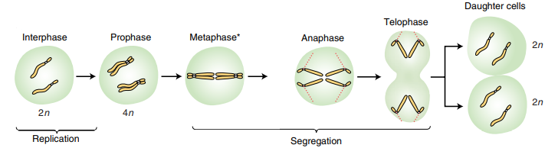

Stages of mitosis:

* **PROPHASE**

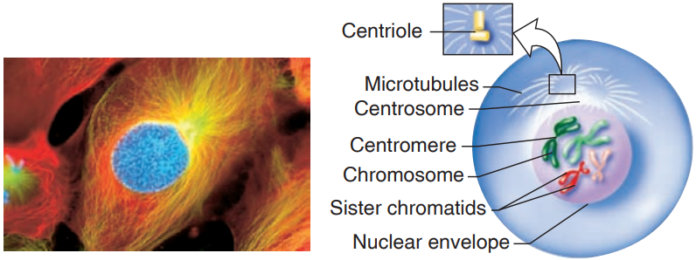During all of interphase, the cell nucleus remains intact, and the chromosomes are indistinguishable aggregates of **CHROMATIN** (resembled mass of extremely fine tangled string). At prophase, the **gradual condensation of individual chromosomes from the mass of chromatin marks the beginning of mitosis**. Each condensing chromosome has already been duplicated during interphase and thus consist of sister chromatids attached at their centromeres.

Moreover, the darkly straining **NUCLEOLI** (region found within the cell nucleus that is concerned with producing and assembling the cell's ribosomes) begin to break down and disappear. As a result, the manufacture of ribosomes ceases as the cell focuses its energy on chromosome movements and cellular division.

Several important events occur outside the nucleus in the cytoplasm. The interphase scaffolding of microtubules is replaced by a set of **dynamic microtubules** that rapidly grow from and shrink back toward their centrosome. Also, **the replicated centrosomes move apart in the opposite ends**.

* **PROMETAPHASE**

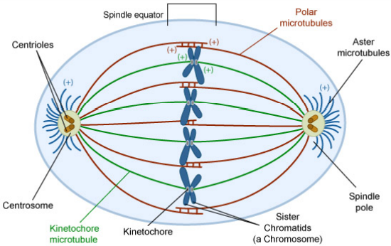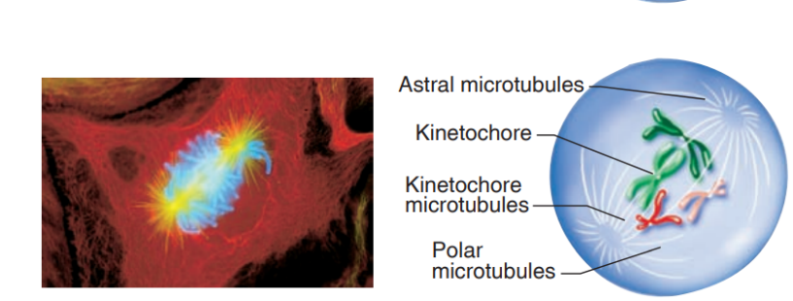Prometaphase begins with the **breakdown of the nuclear envelope** (the membrane separating the nucleus from the cytoplasm), which allows microtubules extending from the two centrosomes to invade the nucleus. **Chromosomes attach to these microtubules** through the **KINETOCHORE**, a structure in the centromere region of each chromatid that is specialized for conveyance. Each kinetochore contains proteins that act as molecular motors, enabling the chromosome to slide along the microtubule. **Microtubules captures chromosomes by connecting to the kinetochore of one of the two sister chromatids at random**. The kinetochore-based motor moves the chromosomes towards the centrosome. As a result, **groups of chromosomes can be observing congregating in the vicinity of each centrosome**. In this early part of prometaphase, for each chromosome, one chromatid’s kinetochore is attached to a microtubule, but the sister chromatid’s kinetochore remains unattached. There are three different types of microtubules fibres that together form the mitotic spindle:

* + **Kinetochore microtubules** (or centromeric fibres) – microtubules that extend between a centrosome and the kinetochore of a chromatid
  + **Polar microtubules** – microtubules from each centrosome directed toward the middle of the cell
  + **Aster microtubules** – short microtubules that extend out from the centrosome toward the cell’s periphery

Soon before the end of prometaphase, **the kinetochore of each chromosome’s previously unattached sister chromatid now associates with microtubules extending from the opposite centrosome**. One sister chromatid faces one pole of cell and the other faces the opposite pole (stable arrangement).

* 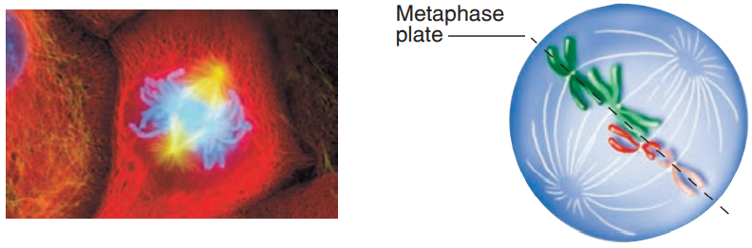**METAPHASE**

During metaphase, the **chromosomes move toward an imaginary equator halfway between the two poles** called the **METAPHASE PLATE**. Chromosome remain at the metaphase place because the microtubule-based forces pulling sister chromatids toward opposite poles are in a balanced equilibrium maintained by tension across the chromosomes. Tensionresult from the fact that the **sister chromatids are pulled in opposite directions while they are still connected to each other in the centromere**.

* **ANAPHASE**

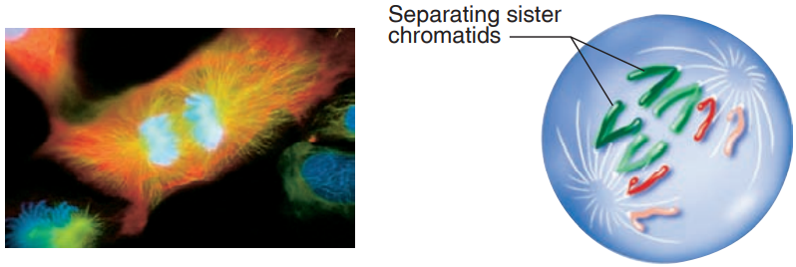During the anaphase there is a nearly simultaneous severing of the centromeric connections between the sister chromatids of all chromosomes. The **separation of sister chromatids** allows each chromatid to be pulled toward the spindle pole to which it is linked by kinetochore microtubules. The kinetochore microtubules become shorter and the chromatids have a characteristic V shape.

**The genetic information migrating toward one pole is exactly the same as it is in the other one**.

* **TELOPHASE**

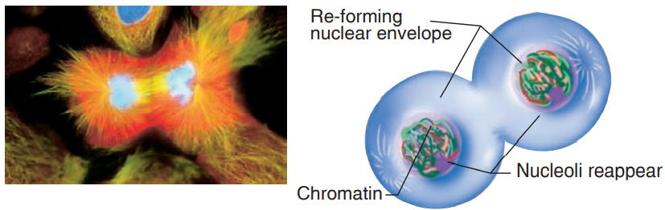Telophase is like prophase in reverse.

The spindle fibres disperse, a nuclear envelope forms around the group of chromatids at each pole, and nucleoli reappear. The former chromatids now function as independent chromosomes, which decondense and dissolve into a tangled mass of chromatin.

* **CYTOKINESIS**

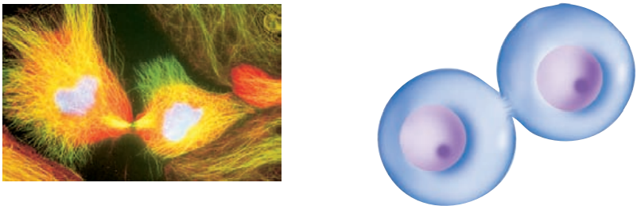In cytokinesis **the parent cell separates into two smaller independent daughter cells with identical nuclei**. Cytokinesis usually begins during anaphase, but it is not completed until after telophase.

In animal cells, a contractile ring pinches the cell into two approximately equal halves.

In plants, whose cells are surrounded by a rigid cell wall, a membrane-enclosed disk, known as the cell plate, forms inside the cell near the equator and then grows rapidly outward, dividing the cell in two.

During cytokinesis, organelles and other cellular components must be parcelled out to the emerging daughter cells. The mechanism accomplishing this task does not appear to predetermine which organelle is destinated for which daughter cell. Instead, because most cells contain many copies of these cytoplasmatic structures, each new cell is bound to receive at least a few representatives of each component. This original complement of structures is enough to sustain the cell until synthetic activity can repopulate the cytoplasm with organelle.

## meiosis

Meiosis consists of **two successive nuclear division**, named meiosis I and meiosis II. In meiosis I, the parent nucleus divides to form two daughter nuclei; in meiosis II, each of the two daughter nuclei divides, resulting in four nuclei. These four nuclei become partitioned in four separate daughter cells because **cytokinesis occurs after both rounds division**. However, **the chromosomes only duplicate at the start of meiosis I**, which explains why the **gametes contains half the number of chromosomes found in somatic cells**.

Stages of meiosis:

* Prophase I
  + **LEPTOTENE**

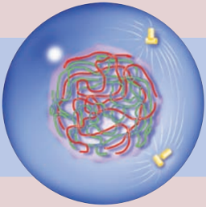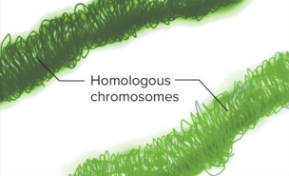The chromosomes begin to thicken becoming visible. Each chromosome has **already duplicated** prior to prophase I and thus consists of **two sister chromatids joined at their centromere** (the sister chromatids are not visible yet).

* + **ZYGOTENE**

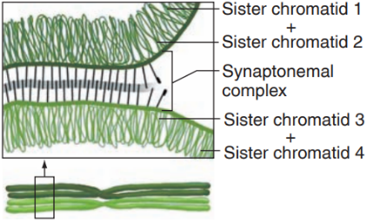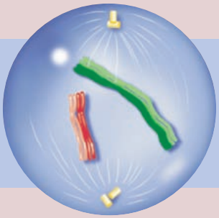Zygotene begins as each chromosomes seek put its **homologous partner** and the matching chromosomes become zipper together in a process known as **SYNAPSIS**. The “zipper” is called **SYNAPTONEMAL COMPLEX**, and it **aligns the homologous juxtaposing the corresponding genetic regions of the chromosome pair**.

* + **PACHYTENE**

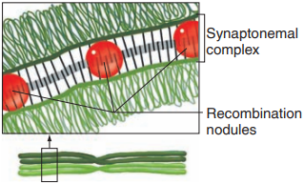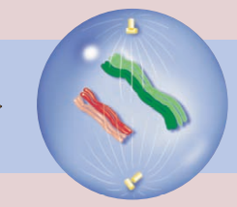

Pachytene begins at the completion of synapsis. Each synapsed chromosome pair is known as bivalent (because it encompasses two chromosomes) or a tetrad (because it contains four chromatids). One side of the bivalent is a maternally derived chromosome, on the other side a paternally derived one. Because **X and Y are not identical, they do not synapse completely**. However, there are some similarities between these two chromosomes that allow them to pair with each other.

During pachytene, structure called **RECOMBINATION NODULES** begin to **appear along the synaptonemal complex**, and an **exchange of parts between non-sister chromatids occurs at these nodules**. Such an exchange is known as **CROSSING-OVER**; it results in the **recombination of generic material**. As a result, chromatids are no longer of purely maternal or paternal origin

* + **DIPLOTENE**

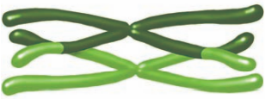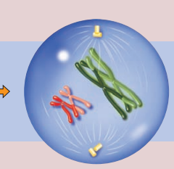

Diplotene is signalled by the **gradual dissolution of the synaptonemal complex** and a slight separation of region of the bivalents, but they **remain connected** at crossover sites, called **CHIASMATA**.

* + **DIAKINESIS**

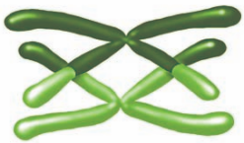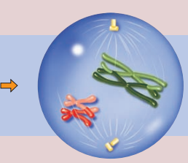Diakinesis is accompanied by **further condensation of the chromatids**. Non-sister chromatids that have exchanged parts by crossing-over remain **closely associated at chiasmata**. The end of diakinesis is analogous to the prometaphase of mitosis: the nuclear envelope breaks down, and the microtubules of the spindle apparatus begin to form.

* Metaphase I

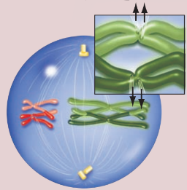During metaphase I **the kinetochore of sister chromatids fuse**, so that each chromosome contains only a single functional kinetochore: it is the kinetochore of homologous chromosomes that attach to microtubules from opposite spindle pole. As a result, in chromosomes aligned at the metaphase plate, the kinetochores of maternally and paternally derived **chromosomes are subject to pulling forces from opposite spindle poles**, balanced by the physical connections between homologous at chiasmata. Because each bivalent’s alignment and hook up is independent of that of every other bivalent, the chromosomes facing each pole are a random mix of maternal and paternal origin.

* Anaphase I

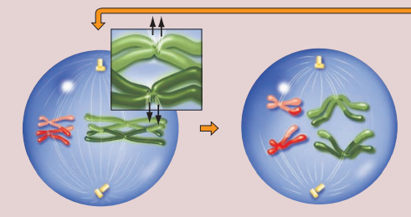At the onset of anaphase I, **the chiasmata joining homologous chromosomes dissolve**. During this phase, the sister centromeres do not separate, thus, from each homologous pair, one chromosome consisting of two sister chromatids segregates to each spindle pole.

Crossing-over play an important role: the chiasmata hold the homologs together and thus ensure that their kinetochores remain attached to opposite spindle poles throughout metaphase. When recombination does not occur within a bivalent, mistakes in hook up and conveyance may cause homologous chromosomes to move to the same pole.

* Telophase I

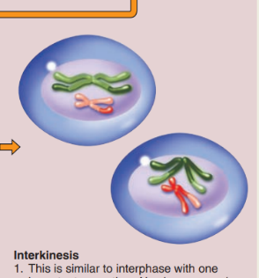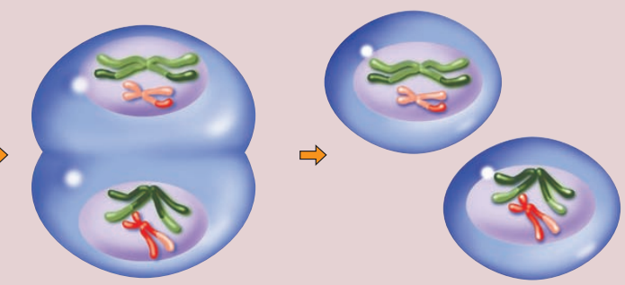The nuclear membranes begin to form around the chromosomes that have moved to the poles. **Each of the daughter nuclei contains one-half the number of chromosomes in the original parent nucleus**, but each chromosome consists of two sister chromatids joined at their centromeres. Because the number of chromosomes is reduced to one-half, meiosis I is often called a **reductional division**.

In most species, cytokinesis follows telophase I, and a short interphase then ensues, in which chromosomes decondense.

No S phase exists during the interphase between meiosis I and meiosis II: the chromosomes do not replicate during meiotic interphase.

The relatively brief interphase between meiosis I and meiosis II is known as **INTERKINESIS**

The second meiotic division proceeds in a fashion very similar to that of mitosis, but because the number of chromosomes in each dividing nucleus has already been reduced by half, the **resulting daughter cells are haploids**.

## comparison between mitosis and meiosis

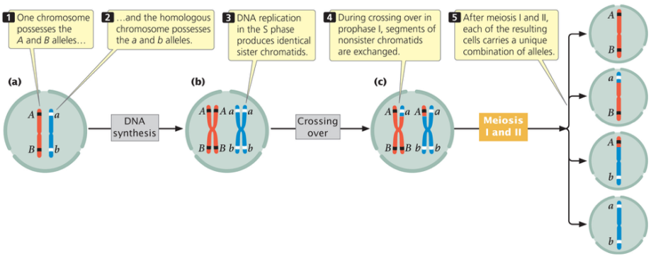Mitosis occurs in all types of eukaryotic cells and is a conservative mechanism that preserve the genetic status quo. Meiosis, on the other hand, occurs only in sexually reproducing organisms, in just a few specialized germ cells within the reproductive organs that produce haploid gametes. It is not a conservative mechanism; rather, the extensive combinatorial changes arising from meiosis are one source of the genetic variation that fuels evolution.

The amount of potential variation generated by meiotic division increases with the number of chromosomes: the number of possible chromosome combinations is 2ⁿ (in human 2²³).

Moreover, the reshuffling of genetic information through crossing-over during prophase I, ensures an even greater amount of genetic diversity in gametes. Because crossing-over recombines maternally and paternally derived genes, each chromosome in each different gamete could consist of different combinations of maternal and paternal information.

## chromosome theory of inheritance

Walter Sutton first outlined the chromosome theory of inheritance. In 1903 he expounded that “***the association of paternal and maternal chromosomes in pairs and their subsequent separation during the reduction division...may constitute the physical basis of the Mendelian law of heredity***". He suggested that chromosomes carry Mendel’s hereditary units for the following reasons:

* Every cell contains two copies of each kind of chromosome, and two copies of each kind of gene.
* During meiosis, homologous chromosomes pair and then separate to different gametes, just as the alternative alleles of each gene segregate to different gametes.
* Maternal and paternal copies of each chromosome pair move to opposite spindle poles without regards to the assortment of any other homologous chromosome pair, just as the alternative alleles of different genes assort independently.
* At fertilization, an egg’s set of chromosome unites with a randomly encountered sperm’s set of chromosomes, just as alleles obtained from one parent unite at random with those from the other parent.
* In all cells derived from the fertilized egg, one-half of the chromosomes and one-half of the genes are of maternal origin, the other half of paternal origin.

The behaviour of chromosomes can be seen to parallel the behaviour of genes.

Walter Sutton’s observations of these parallels led him to propose that chromosome and genes are physically connected in some manner.

# sex-linked inheritance

## sex-linked trait in drosophila

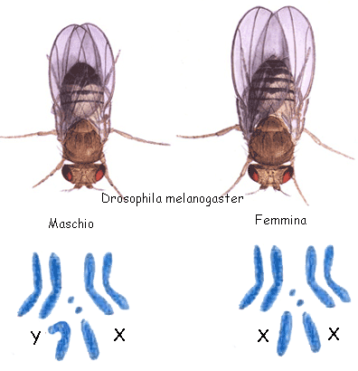Walter Sutton, during his studies, obtain cells from the testes of a grasshopper and observed that the cells contain a total of 24 chromosomes. 22 of them are found in 11 matched pairs, the remaining two chromosomes are unmatched. He called the larger of these the X chromosome and the smaller the Y chromosome. Sutton then concluded that the **X and Y chromosomes determine sex**. Apart from the size, the two sex chromosomes the two sexes are not distinguishable by any other pair of chromosomes.

The American biologist Thomas Hunt Morgan headed the research group whose findings established a firm experimental base for the chromosome theory. Morgan chose to work with Drosophila melanogaster because:

* Short life cycle (~12 days)
* Large progeny
* Easy to rear and cross in the lab
* Only 4 pairs of chromosomes
* Male and female easily distinguished
* Polytenic chromosomes in the salivary glands (very big chromosomes)

Suddenly, a white-eyed male appeared among a large group of flies with brick-red eyes. A mutation had apparently altered a gene determining eye colour, changing it from the normal wild-type allele specifying red to a new allele that produced white. When Morgan allowed the white-eyed male to mate with its red-eyed sisters, all the flies of the F₁ generation had red eyes; the red allele was clearly dominant to the white.

**The wild-type allele is denoted with +, and the recessive mutant allele is denoted with lowercase.**

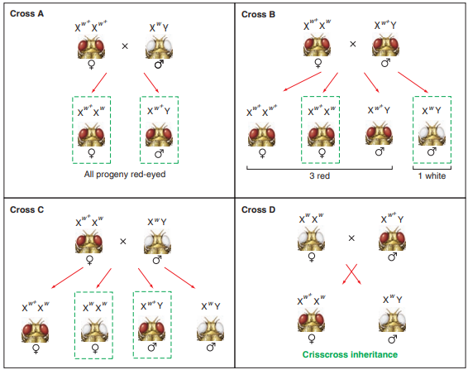 Example: mutant allele (w) specifies white eyes, while the wild-type allele (w⁺) specifies brick-red eyes

Morgan then crossed the red-eyed males of the F₁ generation with their red-eyed sisters and obtained an F₂ generation with the predicted 3:1 ratio of red to white eyes. But there was something askew in the pattern: among the red-eyed offspring, there were two females for every one male, and all the white-eyed offspring were males.

This result was surprisingly **different from the equal transmission to both sexes of the Mendelian traits**! In these fruit flies, **the ratio of various phenotypes was not the same in male and female progeny**!

He continues his experiment by mixing all the possible combination of flies obtaining the results shown in the table.

From the data, Morgan reasoned that the white gene for eye colour is **X-LINKED** (carried by the X chromosome). The Y chromosome carries no allele of this gene. Males, therefore, have only one copy of the gene, which they inherit from their mother. Thus, males are **HEMIZYGOUS** for this eye colour gene, because their diploid cells have half the number of alleles carried by the female on her two X chromosomes. Therefore, **alleles present on the X chromosome of males will be directly expressed in phenotype**.

## chromosome nondisjunction

Calvin Bridges, one of Morgan’s students, found another key piece of evidence. Bridges repeated the cross Morgan had performed between white-eyed females and red-eyed males (crisscross inheritance), but this time he did the experiment on a larger scale. As expected, the progeny of this cross consisted mostly of red-eyed females and white-eyed males. However, about 1 in every 2000 males had red eyes, and about the same small fraction of females had white eyes.

Bridges hypothesized that these **exceptions** **arose through rare events in which the X chromosomes fail to separate during meiosis in females**. He called such failures in chromosome segregation **NONDISJUNCTION**.

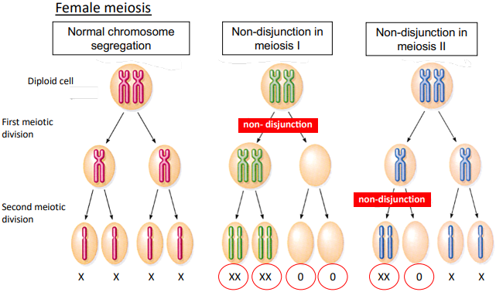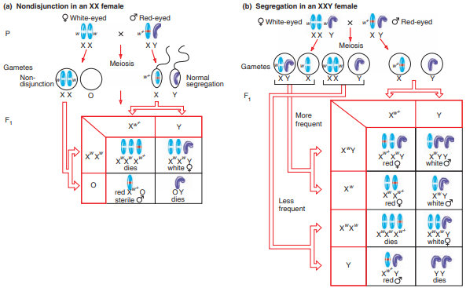Nondisjunction would result in some eggs with two X chromosomes and others with none. Fertilization of these chromosomally abnormal eggs could produce four types of zygotes: XXY (with two X chromosomes from the egg and a Y from the sperm), XXX (with two Xs from the egg and one X from the sperm), XO (with the lone sex chromosome from the sperm and no sex chromosome from the egg), and OY (with the only sex chromosome again coming from the sperm).

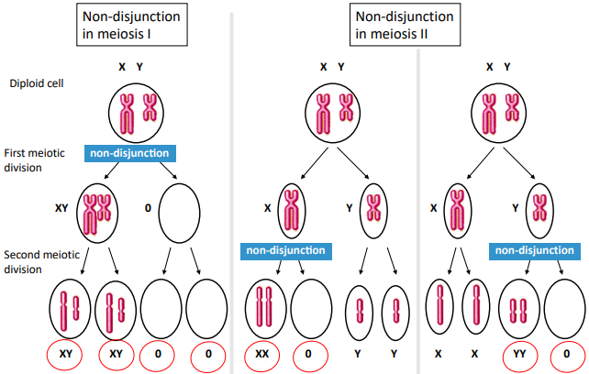When Bridges examined the sex chromosomes of the rare white-eyed females, he found that they were indeed **XXY individuals** who must have received two X chromosomes and with them two w alleles from their white-eyed Xʷ Xʷ mothers. The exceptional red-eyed males emerging from the cross were **XO**; their eye colour showed that they must have obtained their sole sex chromosome from their Xʷ Y fathers. In this study, transmission of the white gene alleles followed the predicted behaviour of X chromosomes during rare meiotic mistakes, indicating that the X chromosome carries the gene for eye colour. These results also suggested that zygotes with the two other abnormal sex chromosome karyotypes expected from nondisjunction in females, **XXX and OY**, **die during embryonic development and thus produce no progeny**. Because XXY white-eyed females have three sex chromosomes rather than the normal two, Bridges reasoned they would produce four kinds of eggs: XY and X, or XX and Y.

The first of these two scenarios occurs more often, because it comes about when the two similar X chromosomes pair with each other, ensuring that they will go to opposite poles during the first meiotic division. The second, less likely possibility happens only if the two X chromosomes fail to pair with each other.

Bridges’ hypothesis was confirmed by observing the chromosome constitutions of the “exceptional” flies on the microscope: **exceptional female flies with white eyes were XXY and exceptional males with red eyes were XO**. Bridges’ experiments showed that the “odd” pattern of inheritance of an X-linked trait was correlated to the “odd” chromosome constitution (XO and XXY), proving that a specific phenotype was associated with a specific complement of chromosomes.

This was considered as the **final confirmation of the chromosome theory of inheritance**.

## sex-linked trait in humans

In Drosophila, sex is determined by the number of X chromosomes (XX= female, X=male) and the Y chromosome is not involved in sex determination.

In humans, it is the presence or absence of the Y that actually makes the difference; that is, any person carrying a Y chromosome will look like a male.

This statement comes from the study of human aneuploids – people whose cells are missing a chromosome or have an extra one.

Example:

* **KLINEFELTER SYNDROME**: rare humans with two X and one Y chromosomes (**XXY**) are **males** displaying certain abnormalities. Klinefelter males are typically tall, thin, and sterile, and they sometimes show mental retardation. That these individuals are males shows that two X chromosomes are insufficient for female development in the presence of a Y.
* **TURNER SYNDROME**: females carrying an X and no second sex chromosome (**XO**) are **females**. Turner females are usually sterile, lack secondary sexual characteristics such as pubic hair, are of short stature, and have folds of skin between their necks and shoulders (webbed necks). Even though these individuals have only one X chromosome, they develop as females because they have no Y chromosome.

X and Y chromosomes have different size and gene content. **The X and Y chromosomes are homologous only at** **PSEUDOAUTOSOMAL REGIONS** (**PARs**), which are essential for XY chromosome pairing in meiosis in the male. In contrast with genes on the Y chromosome, most X chromosome genes have nothing to do with sex; they specify proteins needed by both females and males. The fact that X and Y chromosomes share several genes suggests that the Y chromosome evolved from an X chromosome in an ancient mammal. In the process of becoming Y, this X chromosome gradually lost all of its genes, except those that acquired a specific function in males.

In 1990, researchers discovered that it is not the entire Y chromosome, but rather a single Y-chromosome-specific gene called **SRY** (sex determining region of Y) that it is the **primary determinant of maleness**. The evidence implicating SRY came from so-called sex reversal: the existence of **XX males and XY females**. In many sex-reversed XX males, one of the two X chromosome carries a portion of the Y chromosome, the SRY. Sex-reversed XY females, always have a Y chromosome 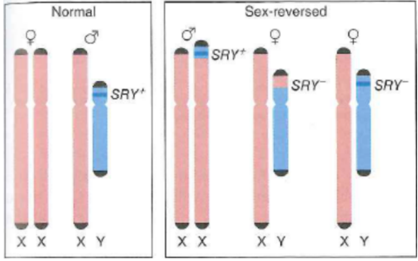lacking a functional SRY gene; the portion of the Y chromosome containing SRY is either replaced by a portion of the X chromosome, or the Y contains a non-functional mutant copy of SRY.

These are **DSD** (difference of sexual development), that are medical conditions encompassing any problem where the genitalia are atypical in relation to the chromosomes or gonads.

* 46, XX DSD: **congenital adrenal hypoplasia** (CAH): impaired cortisol synthesis, excess androgen
* 46, XY DSD: **androgen insensitivity syndrome**: androgen receptor dysfunction, androgen insensitivity.

Later experiment confirmed that **SRY determines the maleness**.

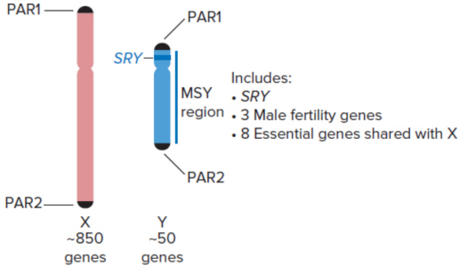Indeed, SRY protein activates testes development in XY embryos. **The embryonic testes secrete hormones that trigger the development of male sex organs**. **In the absence of SRY protein, ovaries develop instead of testes**, and other female sex organs develop by default.

SRY is only one of about 50 protein-coding genes on the human Y chromosome. SRY, as well as three genes required for spermatogenesis, are located in the so-called **male-specific region of the Y** (**MSY**). However, scattered throughout the MSY are several genes that also exist on the X chromosome. These genes affect the function of cells and tissues all over the body. In fact, eight of these shared genes are essential for male viability because without the Y-linked copies the single gene copies on the X chromosome do not supply sufficient protein.

## dosage compensation of x-linked genes

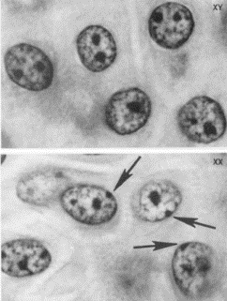The XX and XY system of sex determination presents human cells with a problem that requires a solution called dosage compensation. The X chromosome contains about 850 genes, and the proteins they specify need to be present in the same amounts in male and female cells. **To compensate for female cells having two copies of each X-linked gene and male cells having only one**, **XX cells inactivate one of their two X chromosomes**. Almost all of the genes on the inactivated X chromosome are turned off.

X inactivation occurs at about 2 weeks after fertilization, when a human embryo is composed of only 500/1000 cells. At that time, **each cell chooses one of the X chromosomes at random to condense it into a** so-called **BARR BODY** and inactivate it (from Murray Barr, 1949). The inactive X chromosomes are observable in interphase cells as darkly stained heterochromatin masses.

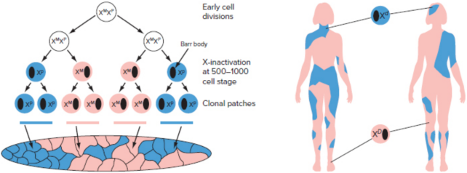Each embryonic cell “decides” independently which X chromosome will be inactivated. Once the determination is made, the decision is clonally perpetuated so that all of the cells descended by mitosis from a particular embryonic cell condense the same X chromosome to a Barr body.

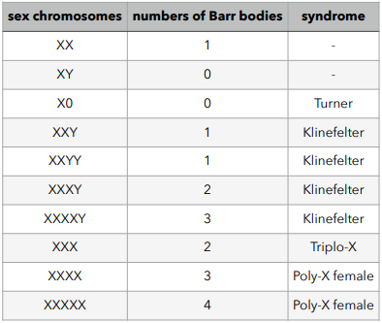The X-chromosome inactivation may have interesting effects on the trait controlled by X-linked genes. **When females are heterozygous at an X-linked gene, some parts of their bodies are in effect hemizygous for one allele, and the other parts are hemizygous for the other allele** in terms of gene function. Moreover, which body parts are functionally hemizygous for one allele or the other is random; even identical twins will have different pattern of X-chromosome inactivation.

Example: females heterozygous for the X-linked recessive trait anhidrotic epidermal dysplasia have patches of skin that lack sweat glands interspersed with patches of normal skin; the character of a patch depends upon which X chromosome is inactivated.

**The PAR genes on the Barr body X chromosome escape inactivation**, as well as some genes in the X-specific region.

The dosage compensation may also explain why XXY males (Klinefelter syndrome) and XO females (Turner syndrome) have abnormal morphological features. Although one of the two X chromosomes in XXY males becomes a Barr body, Klinefelter males have three PAR regions; the single X chromosome in XO cells does not become a Barr body, yet these cells have only one PAR region.

X-inactivation is an epigenetic event. An **EPIGENETIC MECHANISM** is a **heritable, self-perpetuating changes in gene expression not caused by mutation in the base-pair sequence of DNA**. Epigenetic changes can be influenced by the environment; usually, the changes are transmissible through mitosis but not across generation, but there are some epigenetic changes that are actually transmitted.

## chromosomal packaging and gene expression

**Chromatin can be present in different level of packaging: the less frequently a segment of DNA is transcribed, the more it is compacted.**

Chromatin is really **compact during cell division** (it allows to see the structure of chromosomes) and it’s more open during the cell cycle.

**Gene promoters are hidden from RNA polymerase and transcription factors when the promoter DNA is wrapped around the histone core of a nucleosome** (a). Studies of chromatin structure show that the promoters of most inactive genes are indeed wrapped in nucleosome.

The position of nucleosomes can be observed at the molecular level by treating chromatin with **DNase**, an enzyme that cleaves phosphodiester bonds in DNA: sequences within nucleosomes are protected from DNase digestion, while chromosomal regions from which nucleosome have been eliminated are recognizable by their hypersensitivity to DNase cleavage.

When a previously inactive gene prepares for transcription, the promoter region is observed to change from a DNase-resistant site to a DNase hypersensitive site. The reason is that **transcription regulatory proteins bind DNA at nearby enhancers and recruit proteins that reorganize the chromatin in the vicinity** (b).

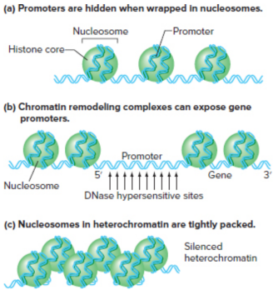There are two types of chromatins:

* **EUCHROMATIN**: **less condensed**. It contains most of the sites of transcription and thus almost all of the genes.
* **HETEROCHROMATIN**: **much more condensed** (much tighter packing of nucleosome, c). Heterochromatin seems to be **transcriptionally inactive**; it is so tightly packaged that the enzymes required for transcription of the few genes it contains cannot access the DNA sequences they bind.

A high proportion of the DNA is located in regions of constitutive heterochromatin (chromosomal regions that remain condensed in heterochromatin at most time in a cell) consists of long stretches of simple repetitive sequences like SSRs. Heterochromatic regions are also repositories for many transportable elements (segment of DNA that move around the genome). SSRs and transportable elements probably accumulate in constitutive heterochromatin because they are transcriptionally silenced there (inactive). Repetitive DNAs and transportable elements constitute more than half of most genomes; their sequestration in transcriptionally inactive heterochromatin provides organisms with a way to minimize the effects of such junk DNA on normal cellular physiology.

Several mechanisms govern the distinction between active euchromatin and silenced heterochromatin. We focus here on **HISTONE TAIL MODIFICATIONS**.

The histones have tails that are coming out from the histone core, and the tail can be modified in different ways. **Enzymes can add several different kinds of chemical groups to various amino acids along these tails, while other enzymes can remove groups that were added previously**. Such modifications of these histone tails can influence the packing of nucleosomes, and the modified tails can also serve as platforms to which chromatin modifier proteins can bind. The histone tail of a nucleosome core potentially could be modified in more than 100 different ways, some of these are:

* **HISTONE ACETYLATION**: addiction of acetyl groups to a specific lysines. It is accomplished by a group of enzymes called histone acetyltransferases (HAT) and **“opens” chromatin by preventing the close packing of nucleosomes**. Histone acetylation thus **favours the expression of genes** in euchromatic regions, because their **promoters are in open chromatin which is accessible to RNA polymerase**. Interestingly, the acetylated lysines on histone tails serves as a binding site for HAT enzymes, thus facilitating the spreading of histone acetylation to neighbouring nucleosomes.
* 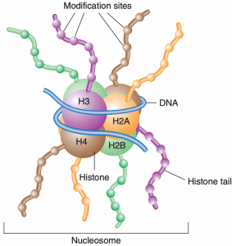**HISTONE DEACETYLATION**: reverse process of acetylation. There are histone deacetylases (HDACs) enzymes that remove acetyl groups. The result is **closed chromatin and repressed transmission**.
* **METHYLATION**: the enzymes that methylate histones are histone methyltransferases (HMTs). They add methyl groups to a specific lysine. This specific methylation **marks the chromatin for assembly into heterochromatin by providing binding sites for heterochromatin-specific proteins**.

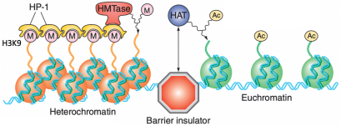

## x chromosome inactivation mechanism

In some cells, the X inherited from the mother is inactivated; in others, it is the X inherited from the father. The inactive X chromosomes, or **Barr bodies**, **are example of facultative heterochromatin**: regions of chromosomes that are heterochromatic in some cells and euchromatic in other cells of the same organism. Most genes on an X chromosome are available for transcription only in cells where the chromosome is euchromatic; in contrast, only few genes are available for transcription on an X chromosome that has become a heterochromatic Barr body.

The X chromosome contain a region of DNA called **X INACTIVATION CENTRE** (XIC) that **mediates dosage compensation** and in which starts the inactivation mechanism. The most important gene in the XIC is called **X*ist*** (*X inactive specific transcript*), that is a **long non-coding RNA molecule** that never leaves the nucleus and is never translated into a protein. As the inactivation process begins, **X*ist* is transcribed only from the future inactive** **X**. A memory is created: the same X inactivated is transmitted throughout DNA replication and cell division.

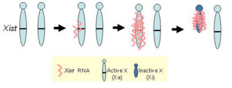Evidence for the role of X*ist* in inactivation includes the following observations:

* An X chromosome that does not contain X*ist* cannot be inactivated.
* Deletion of the X*ist* gene abolishes a chromosome’s capacity for X inactivation.
* Cells carrying one X chromosome that lacks the X*ist* gene must inactivate the other X.

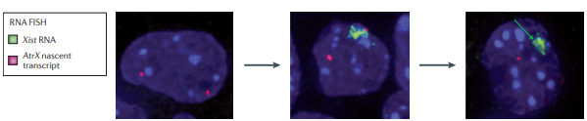

**RNA FISH** (RNA fluorescence in situ hybridization) is a powerful technique that enables the **visualization and localization of RNA and protein targets in fixed cells**.

The blue ball is the nucleus of the cell during interphase.

We can observe:

1. Stem cells (undifferentiated): in red we can see that both chromosomes are active
2. Differentiating cells: in green we can see one of the two chromosomes that’s becoming inactivated (X*ist* is transcribed, starts associating to the chromosome where is transcribed causing histone to modify the structure of the chromatin)
3. Differentiated cells: there is only one red signal (only one chromosome is active and the other one is inactivated) and in green we can see the Barr body

# human pedigree analysis

## 

A family history, known as a pedigree, is an orderly diagram of a family’s relevant genetic features. From systematic pedigree analysis, geneticist can tell if a trait is determined by alternative alleles of a single gene and whether a single-gene characteristic is dominant or recessive to another characteristic. The diagram shows how to interpret a family pedigree diagram.

There are several types of inheritance pattern:

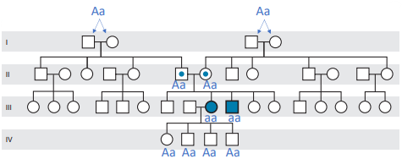

* + **AUTOSOMAL RECESSIVE INHERITANCE**
* **the family pattern of people showing the trait is horizontal**: the parents, grandparents, and great-grandparents do not manifest the disease, while several brothers/sisters in a single generation may;
* parents of an affected child are asymptomatic carriers of mutant alleles;
* males and females are equally likely to be affected;
* the recurrence risk for each sib of the proband is 1 in 4 (25%).

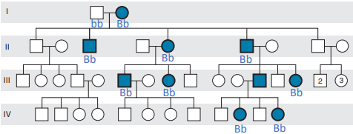

* + **AUTOSOMAL DOMINANT INHERITANCE**
* **the family pattern of people showing the trait is vertical**: the phenotype appears in every generation;
* a child of an affected parent has a 50% risk for inheriting the trait (if the other parent is phenotypically normal);
* males and females are equally likely to transmit the phenotype to children of either sex;
* for rare conditions, almost all affected individuals are heterozygote;
* isolated cases are usually sporadic cases due to new mutation.
  + 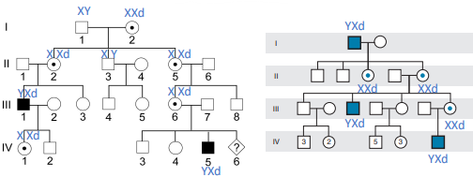**X-LINKED RECESSIVE INHERITANCE**
* the trait **appears in more males than females**, because a female must receive 2 copies of the rare defective allele to display the phenotype, whereas a hemizygous male with only one copy will show it;
* an effected man passes the X-linked mutation to all his daughters, who are thus carriers. Each son of these carrier females has 50% chance to inherit the defective allele, and thus the trait;
* the trait often skips a generation as the mutation passes from grandfather through a carrier daughter grandson;
* the mutant allele is never transmitted directly from father to son;
* isolated cases are often due to new mutation;
* heterozygous females are usually unaffected (but some may express the condition with variable severity as determined by the pattern of X inactivation).
* 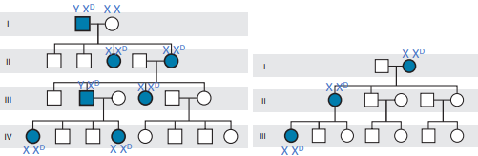**X-LINKED DOMINANT INHERITANCE**
* the trait **appears in more females than males**;
* affected males transmit the phenotype to all the daughters and not to the sons;
* both male and female offspring of female carriers have a 50% risk for inheriting the phenotype;
* for incompletely dominant X-linked traits, carriers females may show the trait in less extreme form than males with the defective allele.

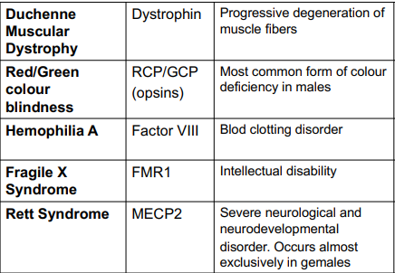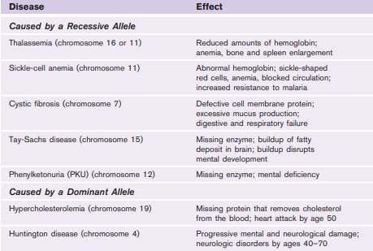 X-linked conditions – examples:

# extensions to mendel’s laws

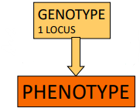Before:

genes are present on homologous chromosomes, which segregate from each

other and assort independently from other chromosomes during gamete

formation.

Mendel assumed that:

* A single gene controlling the phenotype
* Alternative alleles with simple dominant/recessive expression
* No interacting genetic and environmental factors

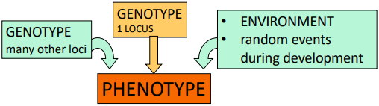While we now know that things are more complex:

## dominance relationships and multiple alleles

Now we know that complete dominance is not the only kind of relationship that can exist between two alleles of a gene. Indeed, crosses between true-breeding straits can produce hybrids with phenotypes that differ from both parents:

* **INCOMPLETE DOMINANCE**

**The heterozygote** does not resemble either homologous parent, but **exhibit a phenotype that is intermediate between those of the pre-breeding parents**. With snapdragons, for example, a crosse between pure-breeding red-flowered parents and pure-breeding white yield hybrids with blossoms of an intermediate pink colour. If allowed to self-pollinate, the F₁ pink-blooming plants produce F₂ progeny bearing red, pink, and white flowers in a ratio of 1:2:1. this is the familiar genotypic ratio of an ordinary single-gene F₁ self-cross. What is new is that because the heterozygotes look unlike either homozygote, **the phenotypic ratios are an exact reflection of the genotypic ones**. The simplest biochemical explanation is that the *A* gene specifies a protein (an enzyme) required for red pigment production. The white allele (*A₂*) does not give rise to a functional enzyme, but the red allele (*A₁*) does. 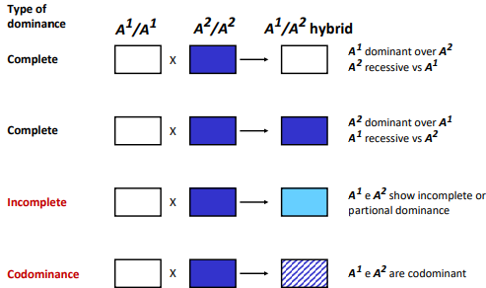Thus, in snapdragons, **two red alleles per cell** (*A₁A₁*) **produce a double dose of a red-producing enzyme**, **which generate enough pigment to make the flowers look fully red**. In the heterozygote (*A₁A₂*), one copy of the red allele per cell results in only enough pigment to make the flowers look pink. In the homozygote (*A₂A₂*), where there is no functional enzyme and thus no red pigment, the flowers appear white.

* **CODOMINANCE**

**Both alleles are simultaneously expressed in the heterozygote**. For example, a cross between pure-breeding spotted lentils and pure breeding dotted lentils produced heterozygotes that are both spotted and dotted. **The progeny looks in part like both parents**, so **neither the spotted nor the dotter allele is recessive or dominant to the other**. Self-pollination of the spotted/dotted F₁ generation generates F₂ progeny in the ratio of 1 spotted:2 spotted/dotted:1 dotted. The Mendelian 1:2:1 ratio among these F₂ progeny establishes that the spotted and dotted traits are determined by alternative alleles of a single gene. Once again, because the heterozygotes can be distinguished from both homozygotes, **the phenotypic and genotypic ratios coincide**.

In humans, some of the alleles that distinguish different types of blood cells exhibit a codominance. For example, one gene *I* with alleles *Iᴬ* and *Iᴮ* controls the presence of a sugar polymer that protrudes from the red blood cell membrane. Each of the alternative alleles encodes a slightly different form of the complex sugar. In the heterozygous individuals, the red blood cells carry both the *Iᴬ*-determined and the *Iᴮ* -determined sugar on their surfaces, whereas the cells of homozygous individuals display the products of either *Iᴬ* or *Iᴮ* alone.

The gene for the ABO blood types has three alleles: *Iᴬ*, *Iᴮ*, and *i*. Allele *Iᴬ* gives rise to blood type A by specifying an enzyme that adds sugar A, *Iᴮ* results in blood type B by specifying an enzyme that adds sugar B; *i* does not produce a functional sugar-adding enzyme. Alleles *Iᴬ* and *Iᴮ* are both dominant to *i*, and blood type O is therefore a result of homozygosity for allele *i*. Note that the A phenotype can arise from two genotypes, *IᴬIᴬ* or *Iᴬi*. The same is true for the B blood type, which can be produced by *Iᴮ Iᴮ* or *Iᴮi*. But a combination of the two alleles *IᴬIᴮ* generates blood type AB.

We can draw several conclusions from these observations:

* + - **a given gene may have more than two alleles**, or multiple alleles; in our example, the series of alleles is denoted *Iᴬ, Iᴮ, i*.
    - although the ABO blood group gene has three alleles, each person carries only two of the alternatives— *IᴮIᴮ, IᴬIᴬ, Iᴮi, Iᴬi, IᴬIᴮ, ii.* There are thus six possible ABO genotypes. Because each individual carries no more than two alleles for each gene, no matter how many alleles there are in a series, Mendel’s law of segregation remains intact, because in a sexually reproducing organism, the two alleles of a gene separate during gamete formation.
    - 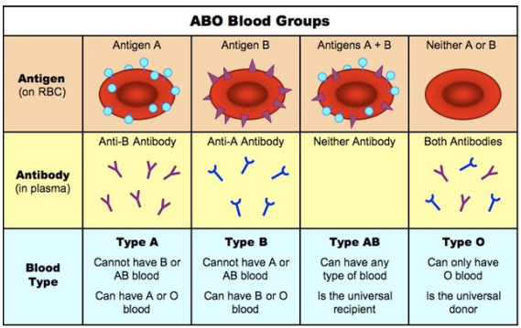**an allele is not inherently dominant or recessive**; **its dominance or recessiveness is always relative to a second allele**. In other words, dominance relations are unique to a pair of alleles. In our example, *Iᴬ* is completely dominant to *i*, but it is codominant with *Iᴮ*. Given these dominance relations, the six genotypes possible with *Iᴬ, Iᴮ* and *i* generate four different phenotypes: blood groups A, B, AB, and O.

An understanding of the genetics of the ABO system has had a profound medical percussion. A person whose cells carry only A molecules, for example, produces anti-B antibodies; B people manufacture anti-A antibodies; AB individuals make neither type of antibody; and O individuals produce both anti-A and anti-B antibodies. These antibodies cause coagulation of cells displaying the foreign molecules. As a result, **people with blood type O have historically been known as universal donors**, because their red blood cells carry no surface molecules that will stimulate an antibody attack in a transfusion recipient. In contrast, **people with blood type AB are considered universal recipients**, because they make neither anti-A nor anti-B antibodies.

## mutations

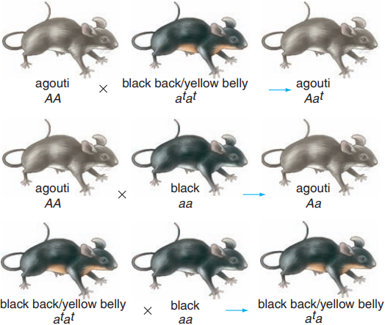The **most common alleles in a population** are usually called **WILD-TYPE ALLELES**. An allele is considered wild-type if it is **present in the population at a frequency greater than 1%**. A rare allele in the same population is considered a **MUTANT ALLELE** (**mutation= alteration of the genetic material**). **The definitions of wild-type and mutant alleles are not static**: if a newly induced mutation generates a mutant allele whose frequency increase over time, the allele can become a wild type.

In mice, for example, one of the main genes determining coat colour is the agouti gene. The wild-type allele (*A*) produces fur with each hair having yellow and black bands that blend together from a distance to give the appearance of dark gray, or agouti. Researchers have identified many distinguishable mutant alleles for the agouti gene: one of these is recessive to the wild type and gives rise to a black coat on the back and a yellow coat on the belly; another is also recessive to *A* and produces a pure black coat. In nature, **wild-type agoutis** (*AA*) **survive to reproduce, while very few black-backed or pure black mutant do because their dark coat makes it hard for them to evade the eyes of predators**. **As a result, A is present at a frequency of much more than 99%** and is thus the only wild-type allele in mice for the agouti gene. A gene with only one wild-type allele is **MONOMORPHIC** (blood type system, that have more than one common allele is polymorphic).

## pleiotropy

The **PLEIOTROPY** occurswhen **one gene influences two or more distinct traits**.

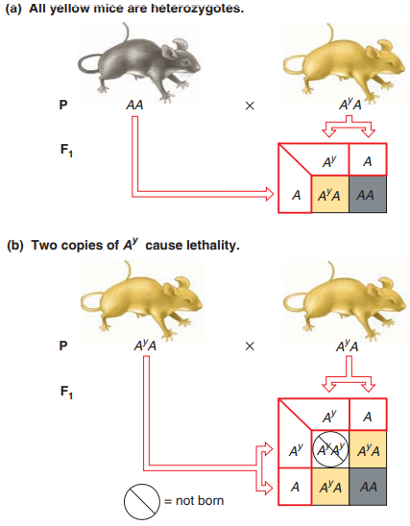Consider the inheritance of coat colour in mice. As mentioned earlier, wild-type agouti (*AA*) animals have black and yellow striped hairs that appear dark gray to the eye. One of the mutant alleles of the agouti gene, *Aʸ,* gives rise to mice with a much lighter, almost yellow colour. When pure-breeding *AA* mice are mated to yellow mice, the offspring always emerge in a 1:1 ratio of the two coat colours. From this result, we can draw three conclusions:

* all yellow mice must carry the wild-type *A* allele even though they do not express the agouti phenotype
* yellow is therefore dominant to agouti
* all yellow mice are *AʸA* heterozygotes.

Note again that dominance and recessiveness are defined in the context of each pair of alleles.

**Mating of yellow to yellow produces an unusual phenotypic ratio of two yellow mice to one agouti**. **There are no pure-breeding yellow mice among the progeny**. When the yellow mice are mated to each other, they produce 2/3 yellow and 1/3 agouti offspring, a ratio of **2:1**, so they must therefore be heterozygotes, and it is impossible to obtain pure-breeding yellow mice.

Two copies of the *Aʸ* allele prove fatal to the animal carrying them, whereas one copy of the allele produces a yellow coat. This means that the ***Aʸ* allele affects two different traits**: **it is dominant to *A* in the determination of coat colour, but it is recessive to *A* in the production of lethality**. An allele, such as *Aʸ*, that negatively affects the survival of a homozygote is known as a **RECESSIVE LETHAL ALLELE**.

Lethal mutations usually remain “silent,” except in rare cases of homozygosity, which in people are often caused by consanguineous matings. **If a mutation produces an allele that prevents production of a crucial molecule, homozygous individuals would not make any of the vital molecule and would not survive**. Heterozygotes, by contrast, with only one copy of the deleterious mutation and one wild-type allele, would be able to produce 50% of the wild-type amount of the normal molecule; this is usually sufficient to sustain normal cellular processes such that life goes on.

## penetrance and expressivity

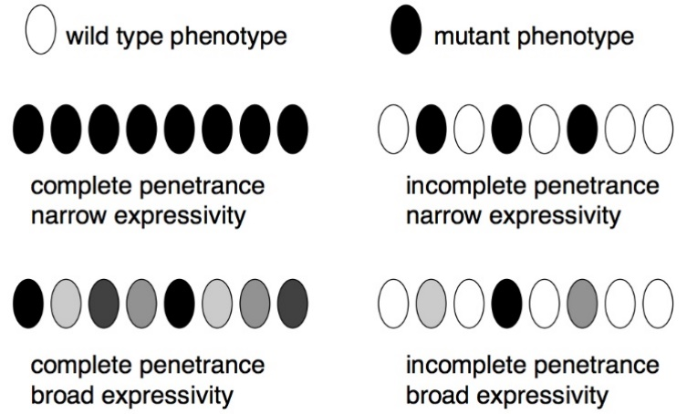**PENETRANCE**: **percentage of individuals having a particular genotype that express the expected phenotype**.

Penetrance can be **complete** (*100%*), as in traits that Mendel studied, or **incomplete**, as in retinoblastoma (penetrance ~ 75%).

**EXPRESSIVITY**: **degree or intensity with which a particular genotype is expressed in the phenotype**.

Expressivity can be **variable** (in some people with retinoblastoma, for example, only one eyes could be affected, while in other individuals with the same genotype both ayes are diseased) or **unvarying** (all *yy* peas are green).

Both are consequence of how gene expression is affected by environment and genetic background.

* **Modifier genes**

Not all genes that influence the appearance of a trait contribute equally to the phenotype. Major genes have a large influence, while modifier genes have a more subtle, secondary effect. Modifier genes alter the phenotypes produced by the alleles of other genes (no formal distinction between major and modifier genes). Modifier genes, for example, influence the length of a mouse’s tail. The mutant *T* allele of the tail-length gene causes a shortening of the normally long wild-type tail. But not all mice carrying the T mutation have the same length tail.

Because all members of each inbred line grow the same length tail, no matter what the environment, geneticists conclude it is genes and not the environment or chance that determines the length of a mutant mouse’s tail. **Different inbred lines most likely carry different alleles of the modifier genes that determine how short the tail will be when the T mutation is present**.

* **Environmental effects on phenotype**

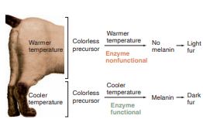**Temperature** is one element of the environment that can have a visible effect on phenotype. For example, temperature influences the unique coat colour pattern of Siamese cats. These domestic felines are homozygous for one of the multiple alleles of a gene that encodes an enzyme catalysing the production of the dark pigment melanin. The form of the enzyme generated by the variant “Siamese” allele does not function at the cat’s normal body temperature. **It becomes active only at the lower temperatures** found in the cat’s extremities, **where it promotes the production of melanin**, which darkens the animal’s ears, nose, paws, and tail. The enzyme is thus **temperature sensitive**. Under the normal environmental conditions in temperate climates, the Siamese phenotype does not vary much in expressivity from one cat to another, but one can imagine the expression of a very different phenotype—no dark extremities—in equatorial deserts, where the ambient temperature is at or above normal body temperature.

Temperature can also affect **survivability**. Drosophila develop and multiply normally at temperatures between 18°C and 29°C; but if the thermometer climbs beyond that cutoff for a short time, they become reversibly paralyzed, and if the temperature remains high for more than a few hours, they die. Thus, at one temperature, the allele gives rise to a phenotype that is indistinguishable from the wild type, while at another temperature, the same allele generates a mutant phenotype (in this case, lethality). **The fact that some mutations are lethal only under certain conditions clearly illustrates that the environment can affect the penetrance of a phenotype**.

# gene interactions and multifactorial inheritance

## genetic heterogeneity

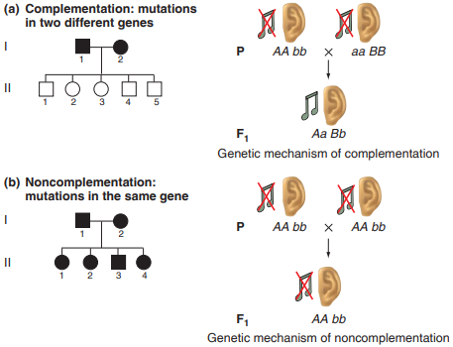**GENETIC HETEROGENEITY**: **the same** (or indistinguishable) **phenotype is due to mutation in different genes**.

It is not always possible to determine which of many different genes has mutated in a person who expresses a heterogeneous mutant phenotype. In the case of deafness, for example, it is usually not possible to discover whether a particular nonhearing man and a particular nonhearing woman carry mutations at the same gene, unless they have children together. If they have only children who can hear, the parents most likely carry mutations at two different genes, and the children carry one normal, wild-type allele at both of those genes. By contrast, if all of their children are deaf, it is likely that both parents are homozygous for a mutation in the same gene, and all of their children are also homozygous for this same mutation.

This **method for discovering whether a particular phenotype arises from mutations in the same or separate genes** is a naturally occurring version of an experimental genetic tool called the **COMPLEMENTATION TEST**. When what appears to be an identical recessive phenotype arises in two separate breeding lines, geneticists want to know whether mutations at the same gene are responsible for the phenotype in both lines. They answer this question by setting up a **mating between affected individuals from the two lines**. If offspring receiving the two mutations express the wild-type phenotype, complementation has occurred. The observation of **COMPLEMENTATION** means that **the original mutations affected two different genes**, and for both genes, **the normal allele from one parent can provide what the mutant allele of the same gene from the other parent cannot**. By contrast, if offspring receiving two recessive mutant alleles express the mutant phenotype, complementation does not occur because the two mutations independently alter the same gene.

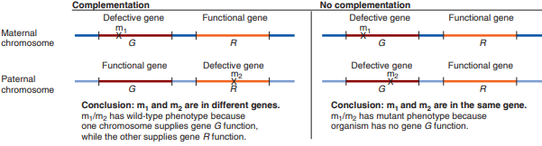**A collection of mutations that do not complement each other is known** as a **COMPLEMENTATION GROUP**. Geneticists often use “complementation group” as a synonym for “gene” because the mutations in a complementation group all affect the same unit of function, and thus, the same gene.

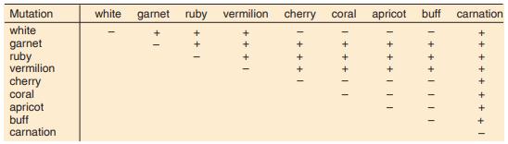

Complementation testing is useful also to understand something more about the eye colour mutation in Drosophila, for example. It, in fact, has shown that garnet, ruby, vermilion, and carnation pigmentation are governed by separate genes. But chromosomes carrying mutations yielding white, cherry, coral, apricot, and buff phenotypes fail to complement each other. These mutations therefore make up different alleles of a single gene. Researches collate data from many complementation tests in a complementation table, that helps visualize the relationships among a large group of mutants.

## additive interaction

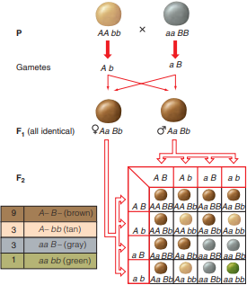Example: we described a mating of tan and gray lentils that produced a uniformly brown F₁ generation and then an F₂ generation containing lentils with brown, tan, gray, and green seed coats.

An understanding of how this can happen emerges from experimental results demonstrating that the ratio of the four F₂ colours is 9 brown: 3 tan: 3 gray: 1 green. This is the same ratio Mendel observed in his analysis of the F₂ generations from dihybrid crosses following two independently assorting genes. In Mendel’s studies, each of the four classes consisted of plants that expressed a combination of two unrelated traits. With lentils, however, we are looking at a single trait — seed coat colour. The simplest explanation for the parallel ratios is that a combination of genotypes at two genes interacts additively to produce the phenotype of seed coat colour in lentils.

For the two genes that determine seed coat colour, **both dominant alleles must be present to yield brown** (*A– B–*); **the dominant allele of one gene produces tan** (*A– bb*); **the dominant allele of the other specifies gray** (*aa B–*); **and the complete absence of dominant alleles** (that is, the double recessive) **yields green** (*aa bb*). Thus, the four colour phenotypes arise from four genotypic classes, **with each class defined in terms of the presence or absence of the dominant alleles of two genes**:

* both present (*A– B–*);
* one present (*A– bb*);
* the other present (*aa B–*);
* neither present (*aa bb*).

Thus, the **9:3:3:1 phenotypic ratio** of brown to tan to gray to green in an F₂ descended from pure-breeding tan and pure-breeding gray lentils tells us that the two genes controlling the same trait probably function additively in independent biochemical pathway, so that in this case, tan (the product of one pathway) + gray (the product of the other pathway) = brown.

## epistasis

**A gene interaction in which an allele of one gene masks the effects of another gene’s allele** is called **EPISTASIS**. The allele that is doing the masking is known as epistasis, while the gene that is being mask is called hypostatic gene.

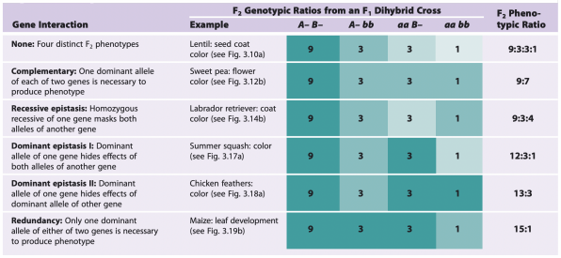

* **RECESSIVE EPISTASIS**

**Homozygosity for a recessive allele of one gene hides the effect of a second gene**. In other words, when an individual is homozygous for the epistatic recessive allele of the first gene, the phenotype is independent of the alleles present at the second gene.

Two examples:

* Labrador retrievers can be black, chocolate brown, or yellow.

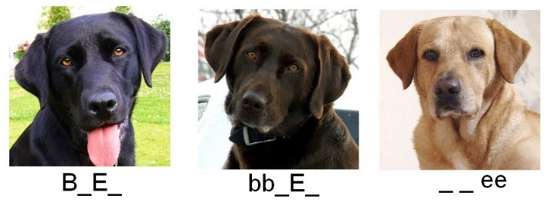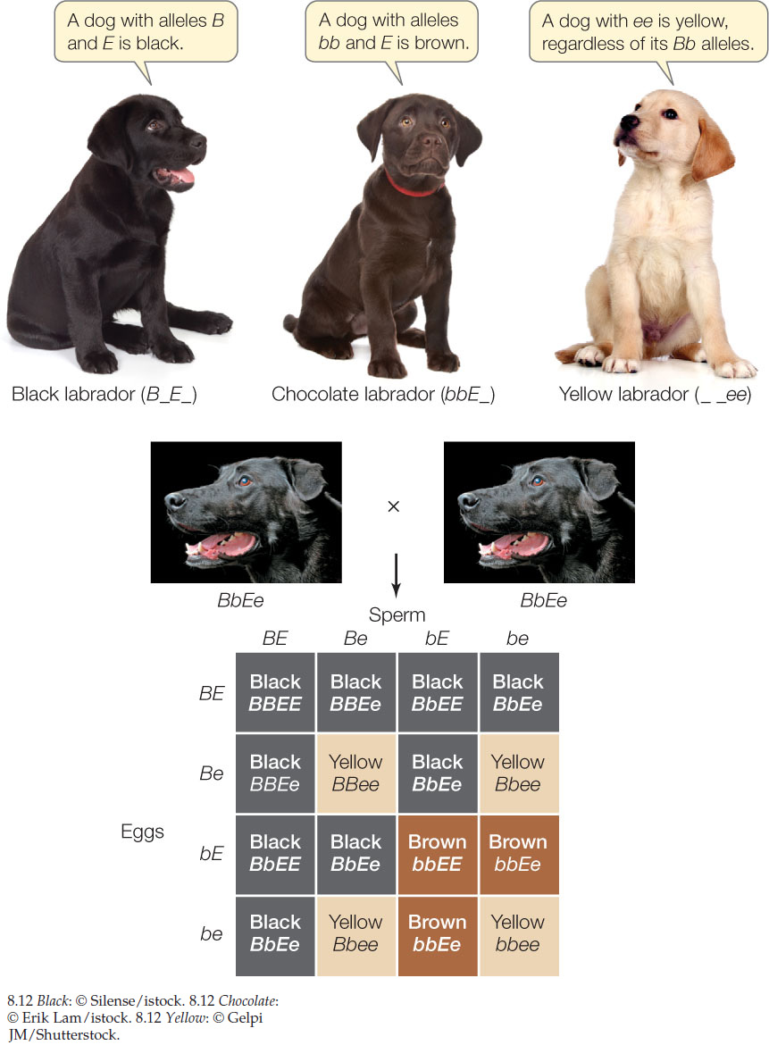Alternative independently assorting alleles of two different genes (gene E and gene B) control these coat colour. When the dominant *E* allele of the first gene is present, the *B* allele of the second gene determine black, and the recessive *bb* homozygote Is chocolate. However, a double dose of the recessive allele *ee* hides the effect of any combination of the black or chocolate alleles to yield yellow. Thus, the recessive *ee* homozygous genotype is epistatic to any allelic combination at the second, hypostatic gene, *B.*

Because the *ee* genotype masks the influence of the other gene for coat colour, you cannot tell by looking at a yellow Labrador whether its genotype is *B­-* (black) or *bb* (chocolate).

All coat colours in dogs comes from two pigments synthesized from a common precursor: a dark pigment called eumelanin and a light pigment called pheomelanin. When Labrador retrievers have at least one copy of the *E* allele, the resultant protein E ensures that the animals will make only eumelanin and no pheomelanin. The protein specified by the *B* allele is required for eumelanin synthesis and its deposition in the hair, while the protein made by the *b* allele is less efficient. As a result, chocolate *E- bb* dogs have less eumelanin in their hairs than black dogs with at least one *B* allele (*E- B-*). But in the absence of the E protein, only pheomelanin is synthesised, and so the dogs appear yellow. ***ee* is epistatic to both alleles of gene *B***: in *ee* dogs, no eumelanin is present, so the dogs are yellow regardless of whether they are *B-* or *bb*.

**Phenotypic ratio 9:3:4**.

* The Bombay phenotype in humans

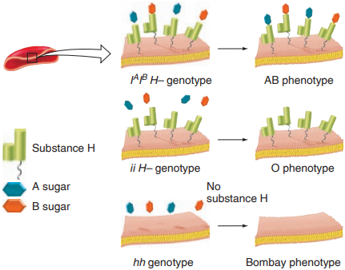In rare instances, two parents who appear to have blood type O, and thus genotype *ii*, produce a child who is either blood type A (genotype *Iᴬi*) or blood type B (genotype *Iᴮi*). This phenomenon occurs because an extremely rare trait, called the **Bombay phenotype**, superficially resembles blood type O. The Bombay phenotype actually arises from **homozygosity for a mutant recessive allele** (*hh*) **of a second gene that masks the effects of any ABO alleles that might be present**.

In the construction of the red blood cell surface molecules that determine blood type, type A individuals make an enzyme that adds polysaccharide A onto a base consisting of a sugar polymer known as substance H; type B individuals make an altered form of the enzyme that adds polysaccharide B onto the base; and type O individuals make neither A-adding nor B-adding enzyme and thus have an exposed substance H in the membranes of their red blood cells. All people of A, B, or O phenotype carry at least one dominant wild-type H allele for the second gene and thus produce some substance H. In contrast, the rare Bombay-phenotype individuals, with genotype *hh* for the second gene, do not make substance H at all, so even if they make an enzyme that would add A or B to this polysaccharide base, they have nothing to add it onto; as a result, they appear to be type O. For this reason, homozygosity for the recessive *h* allele of the H-substance gene masks the effects of the ABO gene, making the *hh* genotype epistatic to any combination of *Iᴬ*, *Iᴮ*, and *i* alleles. A person who carries *Iᴬ*, *Iᴮ* or both *Iᴬ* and *Iᴮ*, but is also an *hh* homozygote for the H-substance gene may appear to be type O, but he or she will be able to pass along an *Iᴬ* or *Iᴮ* allele in sperm or egg. The offspring receiving, let’s say, an *Iᴬ* allele for the ABO gene and a recessive *h* allele for the H-substance gene from its mother plus an *i* allele and a dominant H allele from its father **would have blood type A** (genotype *Iᴬi*, H*h*), **even though neither of its parents is phenotype A or AB**.

* 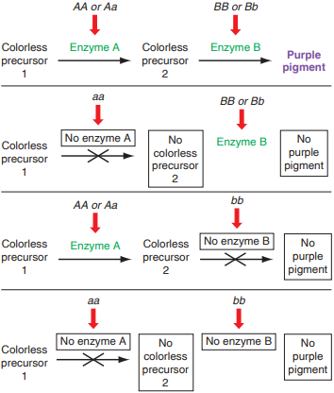**COMPLEMENTARY**

If we make a cross between two lines of pure-breeding white-flowered sweet peas, quite unexpectedly, we obtain all purple flower in the F₁. Self-pollination of these novel hybrids produced a ratio of 9 purple : 7 white in the F₂ generation. **Two genes work in tandem to produce purple sweet-pea flowers, and a dominant allele of both genes must be present to produce that colour**.

Because it takes two enzymes catalysing two separate biochemical reactions to change a colourless precursor into a colourful pigment, only the *A- B-* genotypic class, which produces active forms of both required enzymes, can generate coloured flowers.

The other three genotypic classes (*A– bb, aa B–,* and *aa bb*) become grouped together with respect to phenotype because they do not specify functional forms of one or the other requisite enzyme and thus give rise to no colour, which is the same as white.

The **9:7 ratio** is the phenotypic signature of this type of gene interaction in which the dominant alleles of two genes acting together (*A– B–*) produce colour or some other trait, while the other three genotypic classes (*A– bb, aa B–,* and *aa bb*) do not.

Given that the phenotype associated with either allele A or allele *B* is purple, then we can say that *aa* is epistatic to *B*, and *bb* is epistatic to *A*. if the sweet peas are either *aa* or *bb* their flowers will be white regardless of whether or not they have a dominant allele of the other gene.